**FAKE NEWS DETECTION**

**Introduction:**

Now-a-days we observe that people are receiving fake news through various platforms, but these fake stories are posted on the sites just for entertainment but have no potential to deceive people as result relevant content is shared in the wrong context, these news is created to either earn money or gain publicity. The actual sources are mimic with fake or manipulated sources.

Using the advantages of Blockchain's peer-to-peer network concepts, we will discuss a way to detect fake news in social media. As a result, it describes how to detect fake news by using blockchain technology. The content producer should be registered to blockchain, they will be publishing the news in the blockchain network. Later the content will be verified by the auditors. If the content producer message is not verified then it is classified as fake else real.

**Solution:**

Due to the traceability, transparency and decentralization nature of the block chain, the problem of fake news can be handled effectively. Using the advantages of Blockchain's peer-to-peer network concepts, we will discuss a way to detect fake news in social media.

**Fabric Components:**

Organizations(1): News Agency1

Ordering Service: O1

Ledger(1): L1

Peer(3): NA1 peer1

Channel(1): C1

Certificate Authority: NA1 CA1

**Smart Contract:**

* Providing news into the blockchain platform
* Publishing news
* Verifying news

**High Level Diagram:**

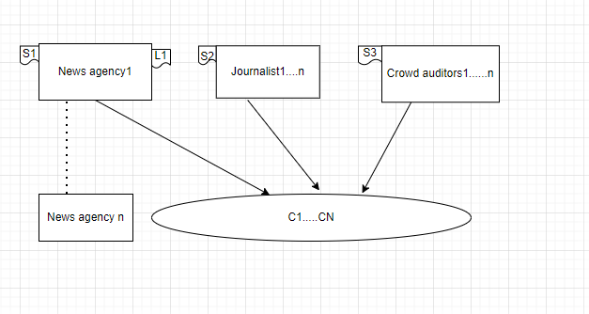

**Pseudo Code:**

